Project 2 Overview
Nicholas Gurrieri
EDU 625
Dr. Milhauser

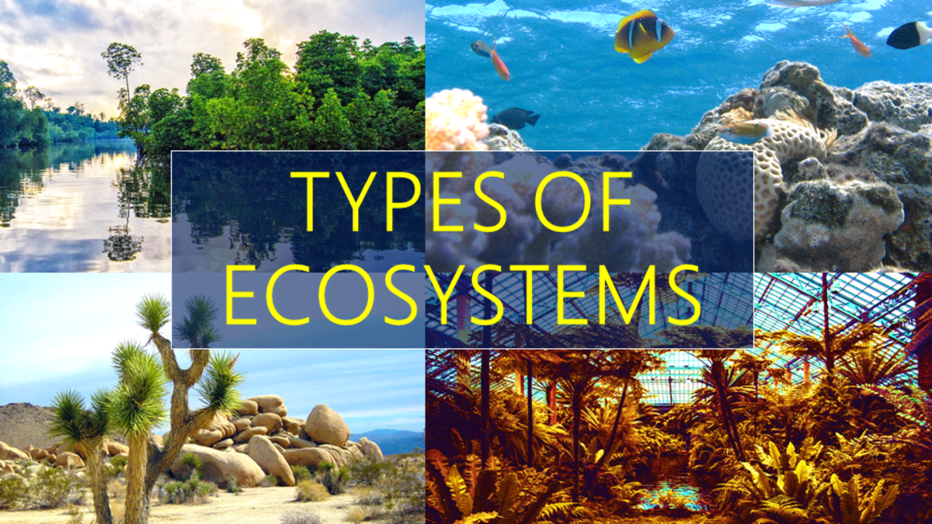
Part I: Project Overview

Topic of Focus | These projects and activities will focus on terrestrial ecosystems.
Audience | This project will be intended for students in grade 3. The learning goal will be aligned with Next Generation Science Standards for grade 3 students.
Rationale  Standards:  Third graders must be able to  make a claim about the merit of a solution to a problem caused when the environment changes and the types of plants and animals that live there may change  (NGSS, 2013). | The fourth activity for this set of projects that students will complete will incorporate mobile e Learning software. This activity will have students make a claim about the merit of 3 possible solutions to a problem caused by animal migration. The reason why I chose to use mobile e Learning software is because it can increase student engagement, and lends itself to higher order thinking tasks, such as collaborating and problem solving (Stanaityte et. al, 2013). This lesson includes both of those tasks.
Sub-topics | The sub-topics that will be covered in this project are related to the 4 types of terrestrial ecosystems. The 4 sub-topics related to terrestrial ecosystems are tundras, grasslands, forests, and deserts. These all relate to the overarching topic of ecosystems, and by the end of the project, the goal will be for students to be able to understand how the organisms that inhabit these ecosystems are suited for living in them. They will also be able to make a claim about the merit of a solution to a problem caused by environmental changes.

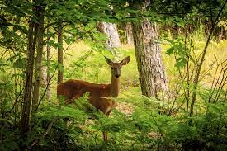
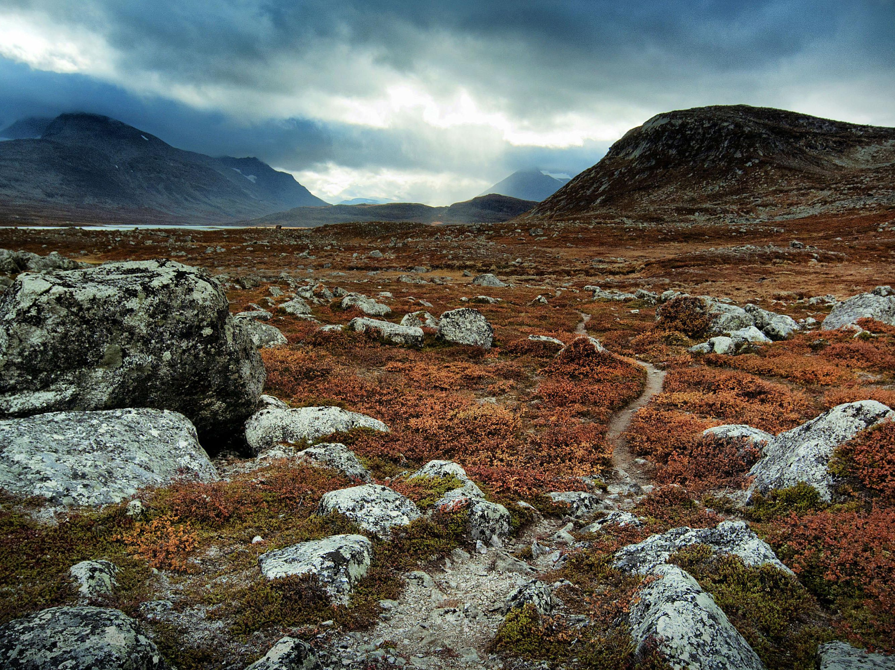
Part II: Content Module

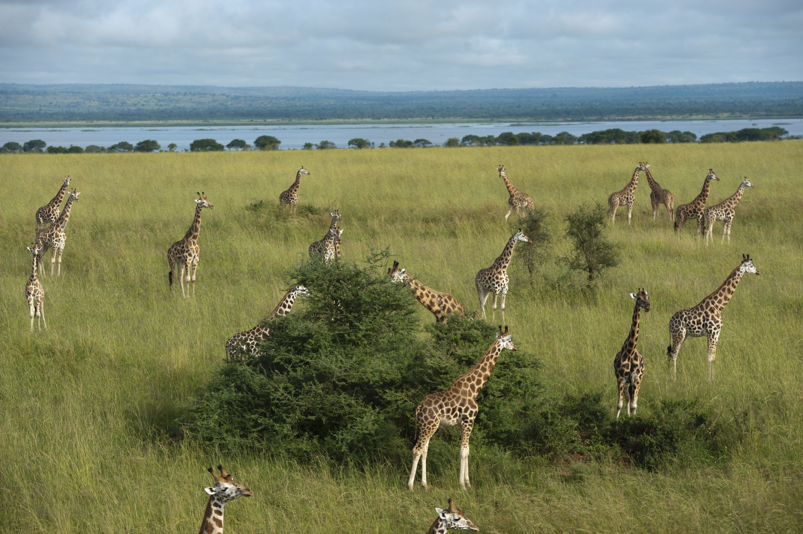
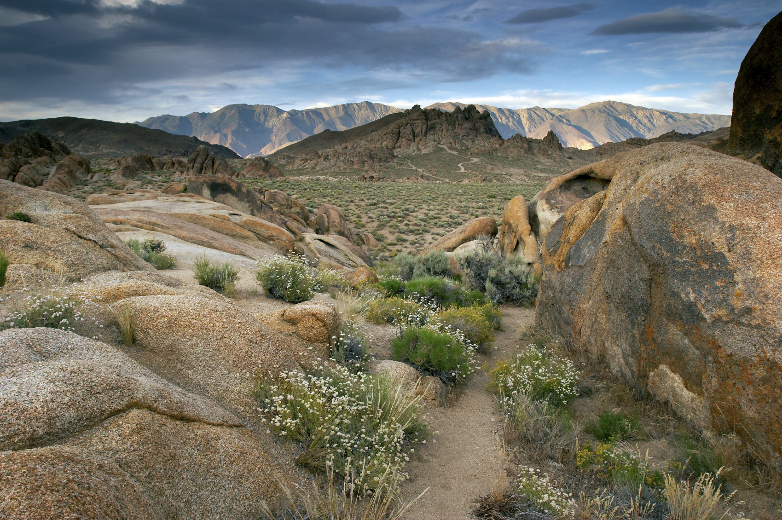

Sub-topic 3 Outline | The next sub-topic that this project will focus on are tundra environments.
Objectives | Students will be able to compare and contrast tundra environments with deserts.  Students will be able to compare and contrast the two different types of tundras.  Students will be able to identify environmental changes that may impact the animals in a specific environment.  Students will be able to make a claim about the merit of a solution for a problem caused by environmental changes.
Instructions | - Begin by accessing join.nearpod.com on your phone, or by accessing the nearpod app  - Input the code to access the video: PKZ62  - The video contains 4 questions that will be asked throughout the video.  - “What do you already know about Tundras?”  - “Compare Tundras with Desert biomes. How are they similar? How are they different?  - “Which of the tundra ecosystems experience permafrost?  - “What type of impact do you think that the changing environment in the tundra can have on the animals that live there?”  - Next, view the next slide. The slide features a description of the problem that Alberta, Canada is facing in regards to animal migration in their northern border, which is an arctic tundra.  - Read the problem, and then “Your Task”  - Open the PDF, and then read the design descriptions for each company  - Review the criteria and constraints of the design.  - With your groups, discuss which designs are best, and select the best design using the poll.  - Using the collaborative board, create your claim, evidence, and reasoning to support your decision about which design solution would be the best.
Activity
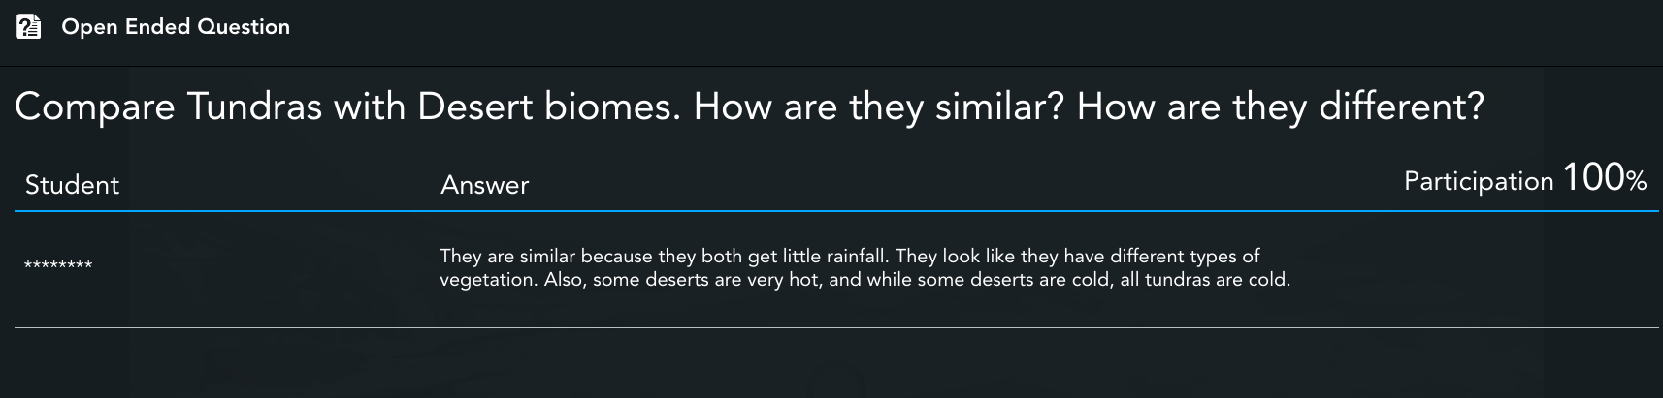
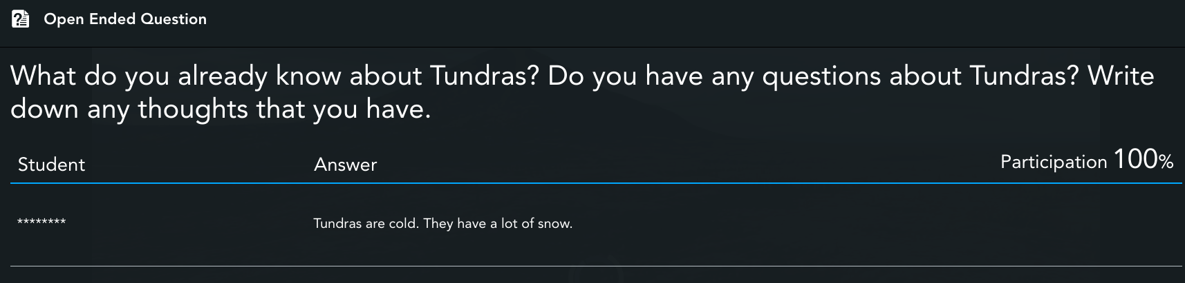
Below you will see the responses to the questions in the initial introductory activity on Nearpod. These responses are collected for the instructor and can be viewed afterwards. Here are some samples of answers that could be generated by students.

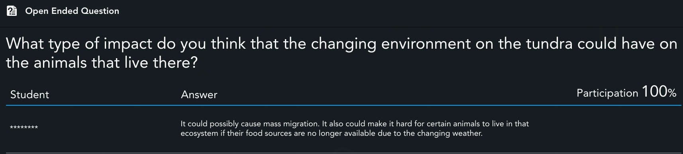
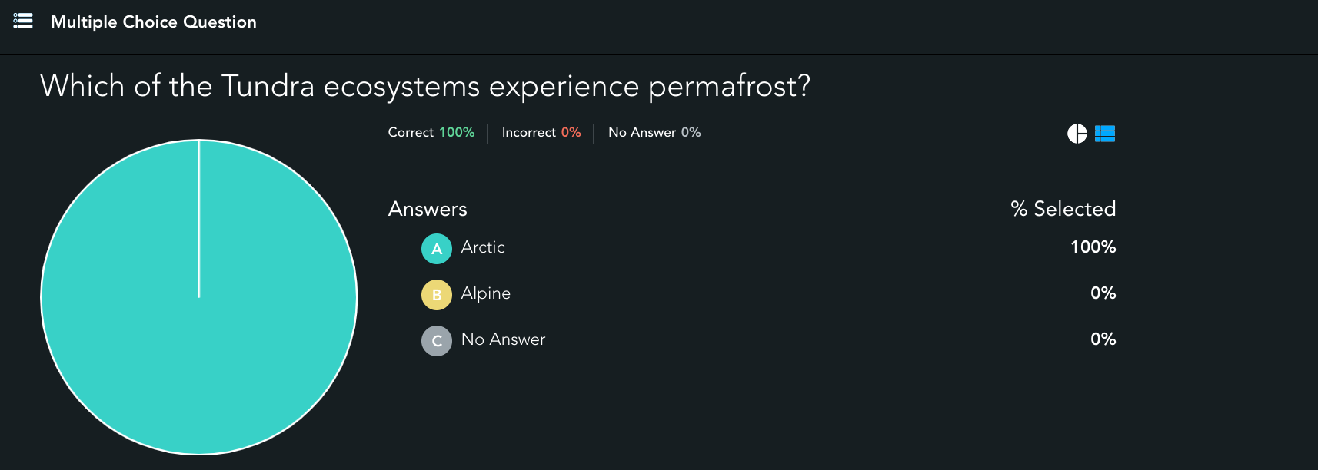

These are what students will see next on Nearpod after watching the introductory video.
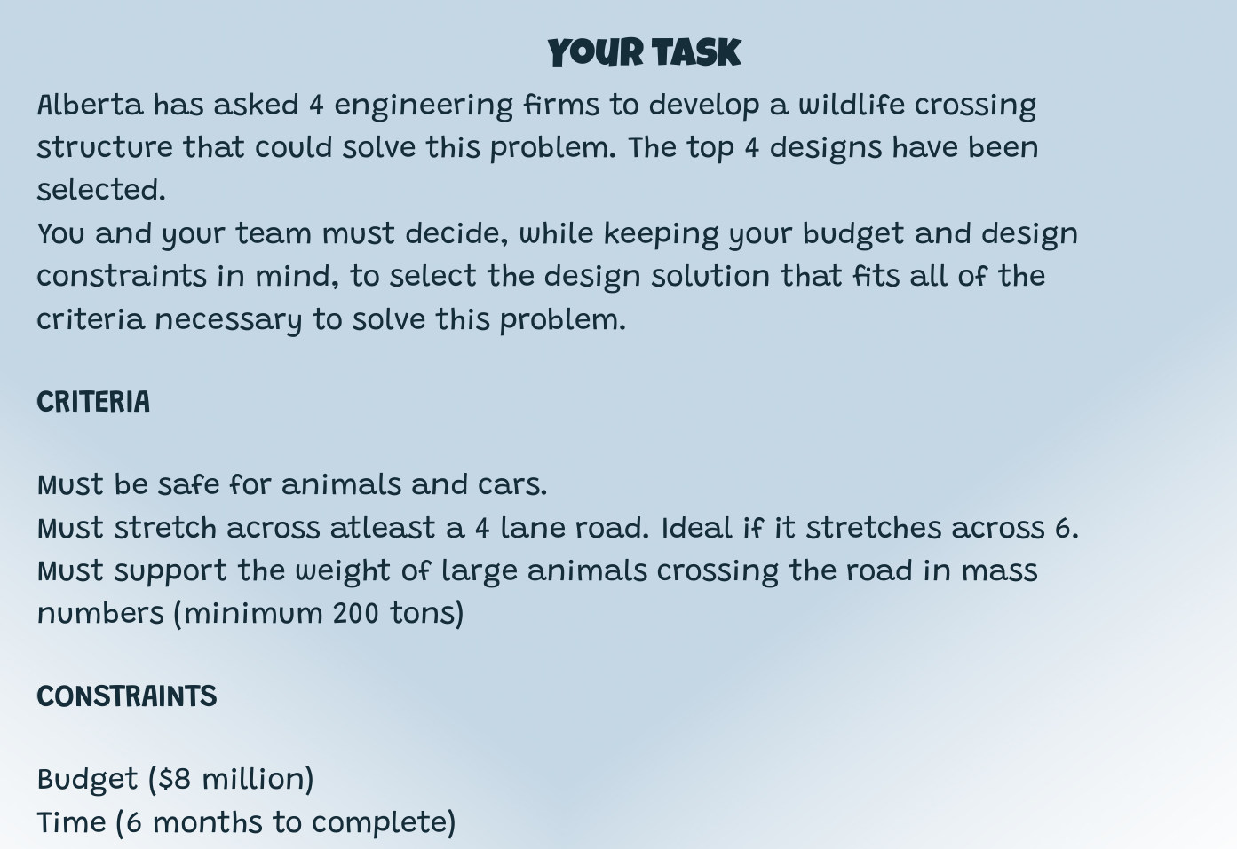
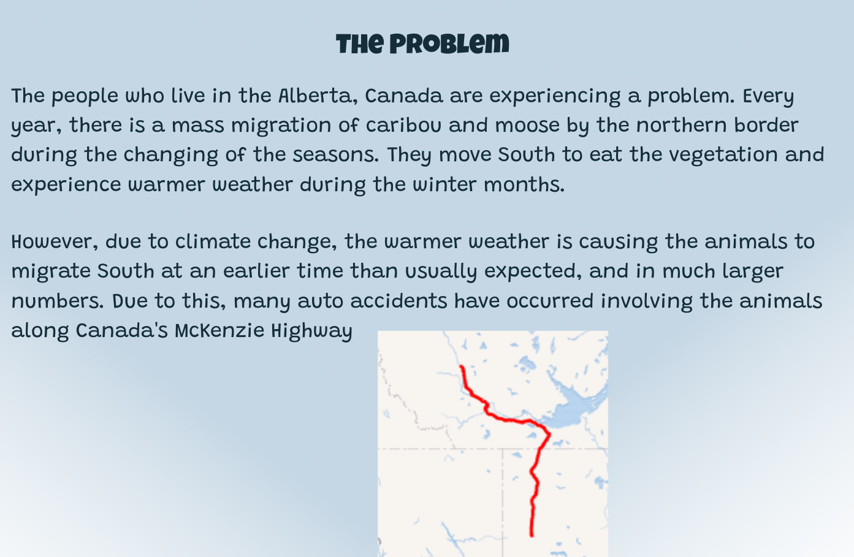

The design solutions
The collaborate board



References
National Geographic Society. (2020, February 5). Tundra Biome.
https://www.nationalgeographic.org/encyclopedia/tundra-biome/#:%7E:text=Arctic%20t
undra%20are%20found%20on,overnight%20temperatures%20fall%20below%20freezing
Next Generation Science Standards. (2013). 3-LS4-4 Biological Evolution: Unity and Diversity |
Next Generation Science Standards.
https://www.nextgenscience.org/pe/3-ls4-4-biological-evolution-unity-and-diversity
Stanaityte, J., Washington, N., Wankel, L. A., & Blessinger, P. (2013). Increasing student
engagement and retention using mobile applications: Smartphones, Skype and texting
technologies. Bingley, U.K.: Emerald.

.

