Project 2 Overview
Nicholas Gurrieri
EDU 625
Dr. Milhauser

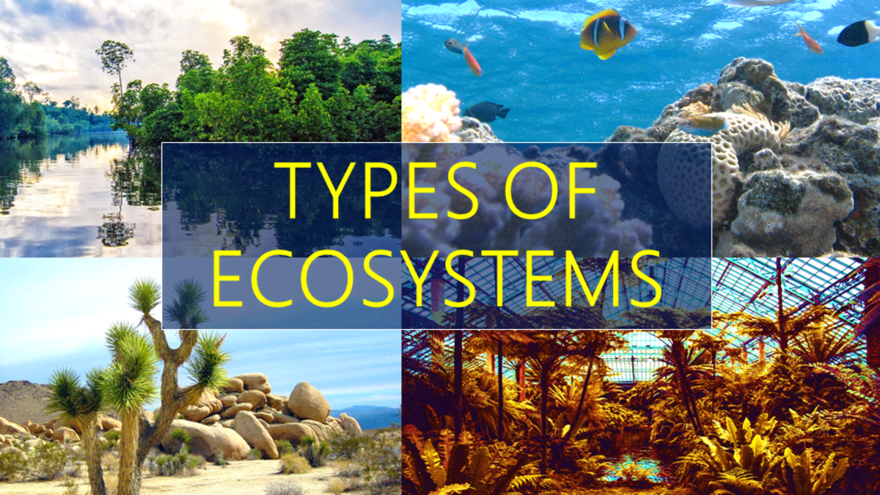
Part I: Project Overview

Topic of Focus | These projects and activities will focus on terrestrial ecosystems.
Audience | This project will be intended for students in grade 3. The learning goal will be aligned with Next Generation Science Standards for grade 3 students.
Rationale  Standards:  Third graders must be able to  use evidence to construct an explanation for how the variations in characteristics among individuals of the same species may provide advantages in surviving, finding mates, and reproducing.  (NGSS, 2013). | The third activity for this set of projects that students will complete will involve the construction of a virtual, imaginary animal that showcases their understanding of how different characteristics among individuals of the same species may provide advantages in surviving, finding mates, and reproducing. The creation of an animal makes sense, as creating is a higher order task. Game principles can engage students, and the creation engine that Spore provides is engaging and will remind many students of “create your own character” mechanics in many video games (Kiang, 2014). Also, the virtual reality aspect of the initial part of the lesson allows students to immerse themselves in a digital environment without them having to leave the classroom, which is a benefit of using virtual reality technology in the classroom (Lynch, 2020).
Sub-topics | The sub-topics that will be covered in this project are related to the 4 types of terrestrial ecosystems. The 4 sub-topics related to terrestrial ecosystems are tundras, grasslands, forests, and deserts. These all relate to the overarching topic of ecosystems, and by the end of the project, the goal will be for students to be able to understand how the organisms that inhabit these ecosystems are suited for living in them.

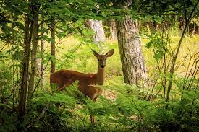
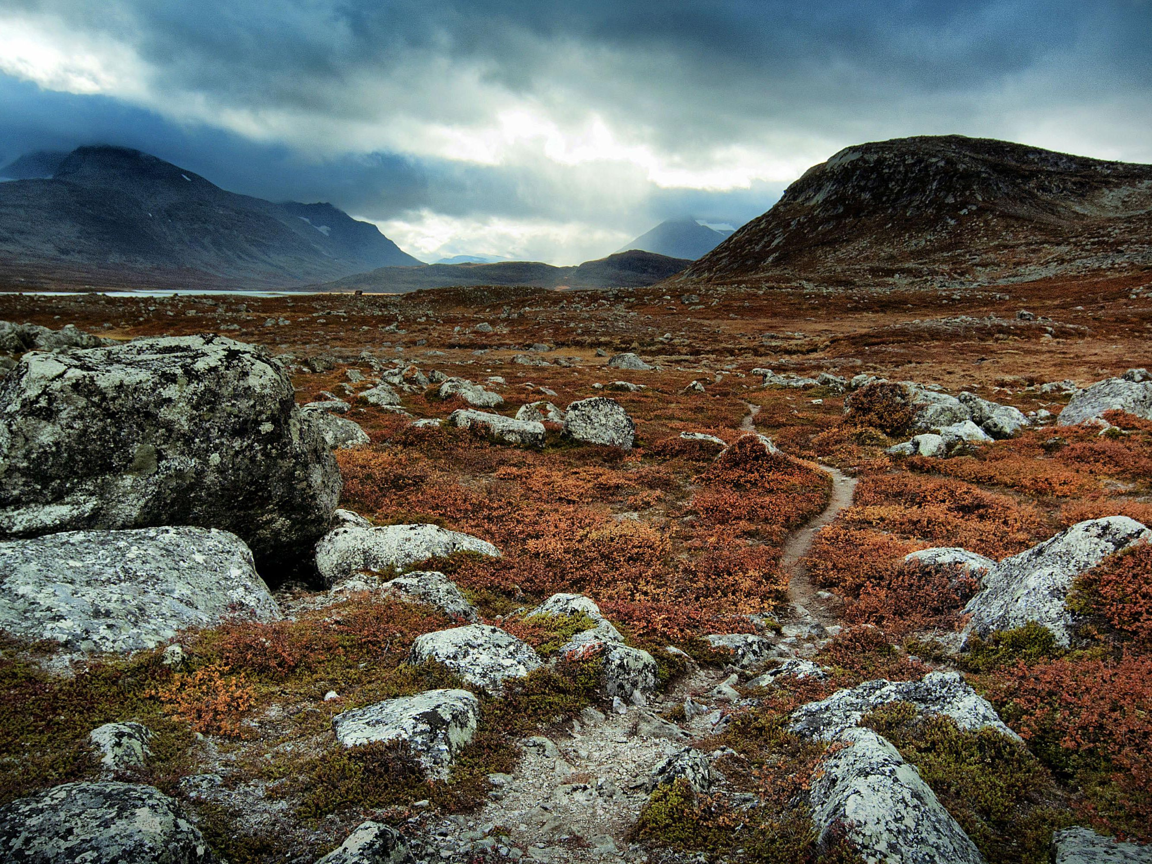
Part II: Content Module

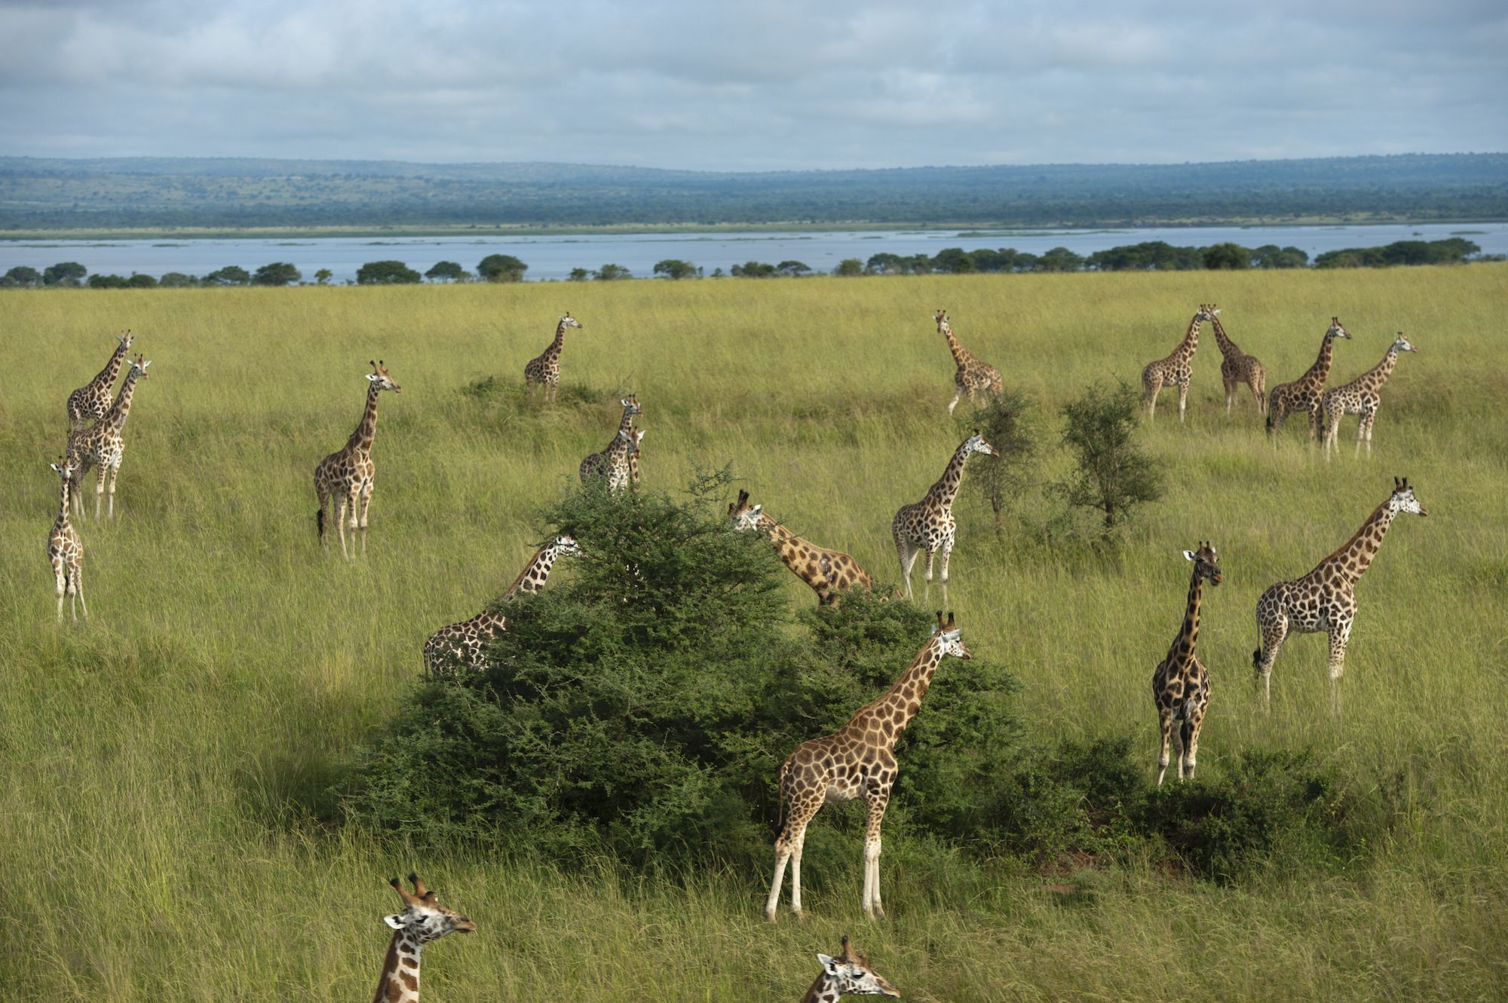
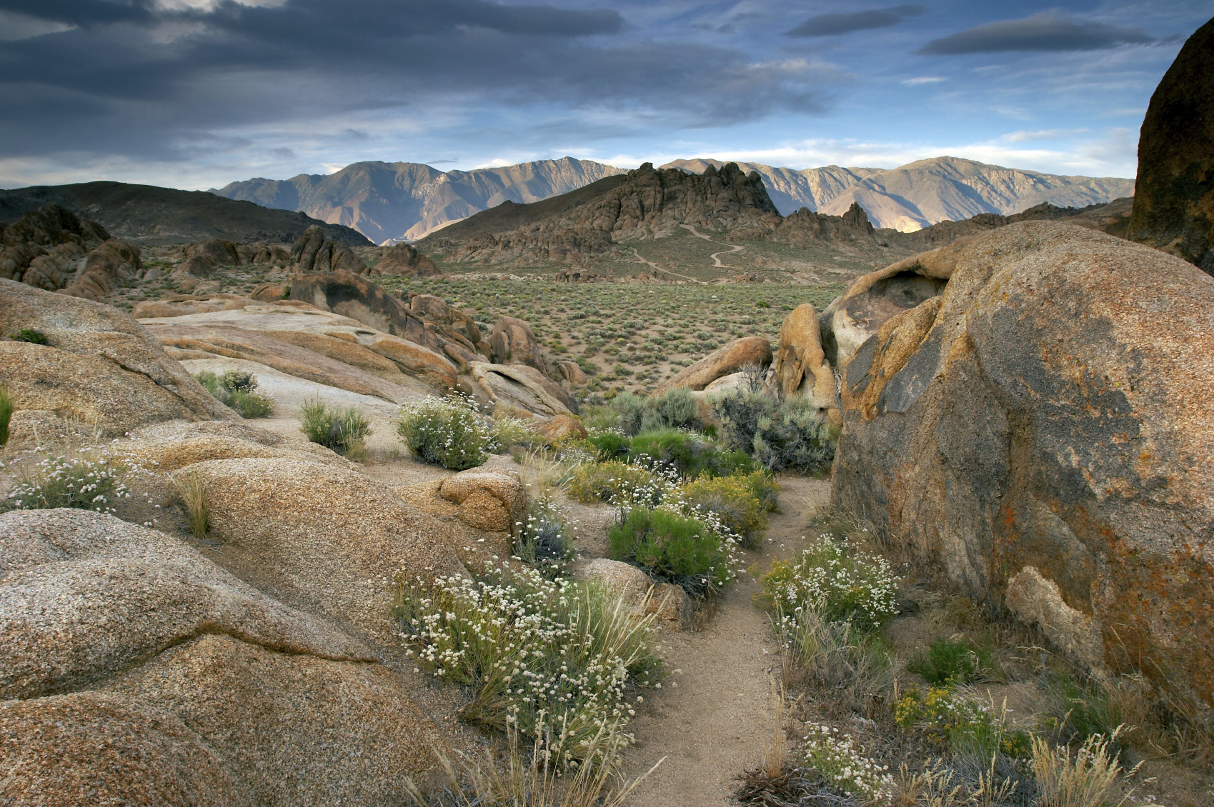

Sub-topic 3 Outline | The next sub-topic that this project will focus on is arid deserts.
Objectives | Students will be able to describe the relationship between environmental factors and adaptations.  Students will be able to create an animal with the necessary traits to survive in an arid desert ecosystem.  Students will be able to justify their claim using evidence.
Instructions | - Visit join.nearpod.com to access the student portal. Input the code to begin the virtual field trip. The code is ELRJZ  - Participate in all 4 virtual field trips. As you do, take note of the aspects of the environment. What do you notice about the vegetation? What do you notice about the terrain in these ecosystems?  - Watch the video about deserts. As you watch the video, what are some things that an animal may need to have in order to survive in this ecosystem?  - Use the class discussion board to answer the discussion question.  - What are some things that animals need to be able to do to live in this environment?  - Visit the Spore Creature Creator application. Using the Creature Creator, develop your own imaginary animal that has the necessary adaptations/ traits to survive in this ecosystem. Explain 3 of the animal’s traits, and why they help the animal survive in the desert.
Activity
Nearpod Virtual Activity: Virtual Field Trip/ Discussion Question Preview
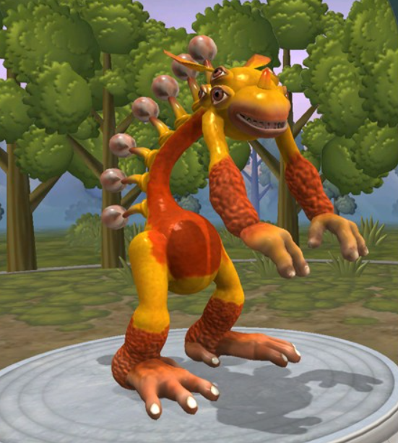
This is my virtual animal. The animal has flat teeth for eating vegetation, and powerful, durable feet for navigating the rough terrain of the desert. It has a rough tongue so it can eat cactuses without getting hurt. The animal has humps on its back just like a camel for storing water, since deserts do not contain much water.

References
Next Generation Science Standards. (2013). 3-LS4-4 Biological Evolution: Unity and Diversity |
Next Generation Science Standards.
https://www.nextgenscience.org/pe/3-ls4-4-biological-evolution-unity-and-diversity
Kiang, D. (2014, October 24). Using Gaming Principles to Engage Students. Edutopia.
https://www.edutopia.org/blog/using-gaming-principles-engage-students-douglas-kiang
Lynch, M. (2020, September 4). How Can Teachers Use VR In The Classroom. The Tech
Edvocate.
https://www.thetechedvocate.org/how-can-teachers-use-vr-in-the-classroom/#:%7E:text= Virtual%20reality%20can%20also%20be,natural%20science%20or%20biology%20class es.&text=VR%20is%20sometimes%20used%20to,that%20are%20taught%20in%20scho ol.

