Project 1 Overview
Nicholas Gurrieri
EDU 625
Dr. Milhauser

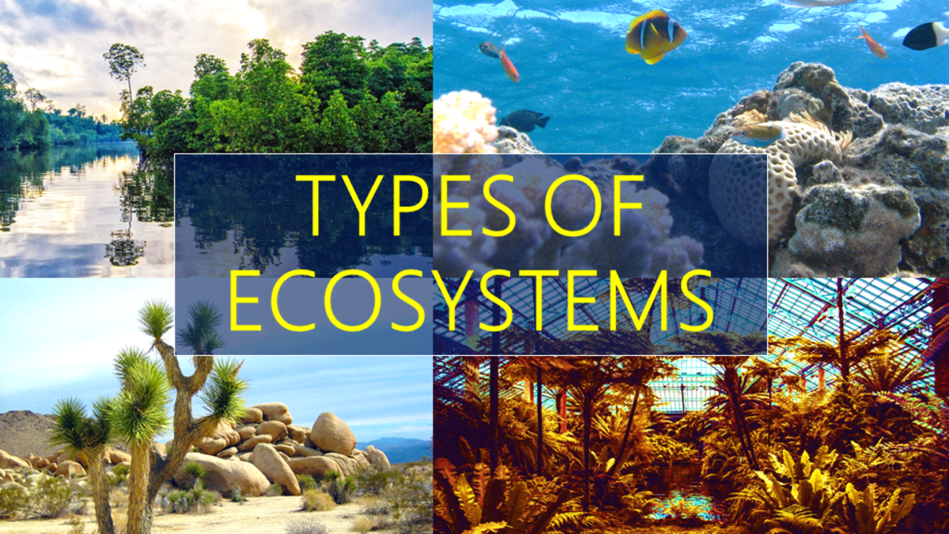
Part I: Project Overview

Topic of Focus | These projects and activities will focus on terrestrial ecosystems.
Audience | This project will be intended for students in grade 3. The learning goal will be aligned with Next Generation Science Standards for grade 3 students.
Rationale  Standards:  Third graders must be able to construct arguments that some animals form groups that help members survive, and also construct an argument with evidence that in certain habitats some animals can survive well, some survive less well, and some cannot survive at all (NGSS, 2013). | The first activity for this set of projects that students will complete will be a mind-map that students need to create that showcases their understanding of the idea that certain organisms can survive in a particular ecosystem, while some other organisms cannot. The specific visual of a mind map makes sense, as it will make it easy to see the connections between the ecosystems and the organisms that inhabit them. Standard note-taking involves making a hierarchical list of information, whereas a mind map can differentiate between ideas and concepts with shapes, colors, and images (Petro Jr., 2010). Also, our brains are primed for visual learning (Nalder, 2009)
Sub-topics | The sub-topics that will be covered in this project are related to the 4 types of terrestrial ecosystems. The 4 sub-topics related to terrestrial ecosystems are tundras, grasslands, forests, and deserts. These all relate to the overarching topic of ecosystems, and by the end of the project, the goal will be for students to be able to understand how the organisms that inhabit these ecosystems are suited for living in them.

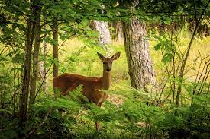
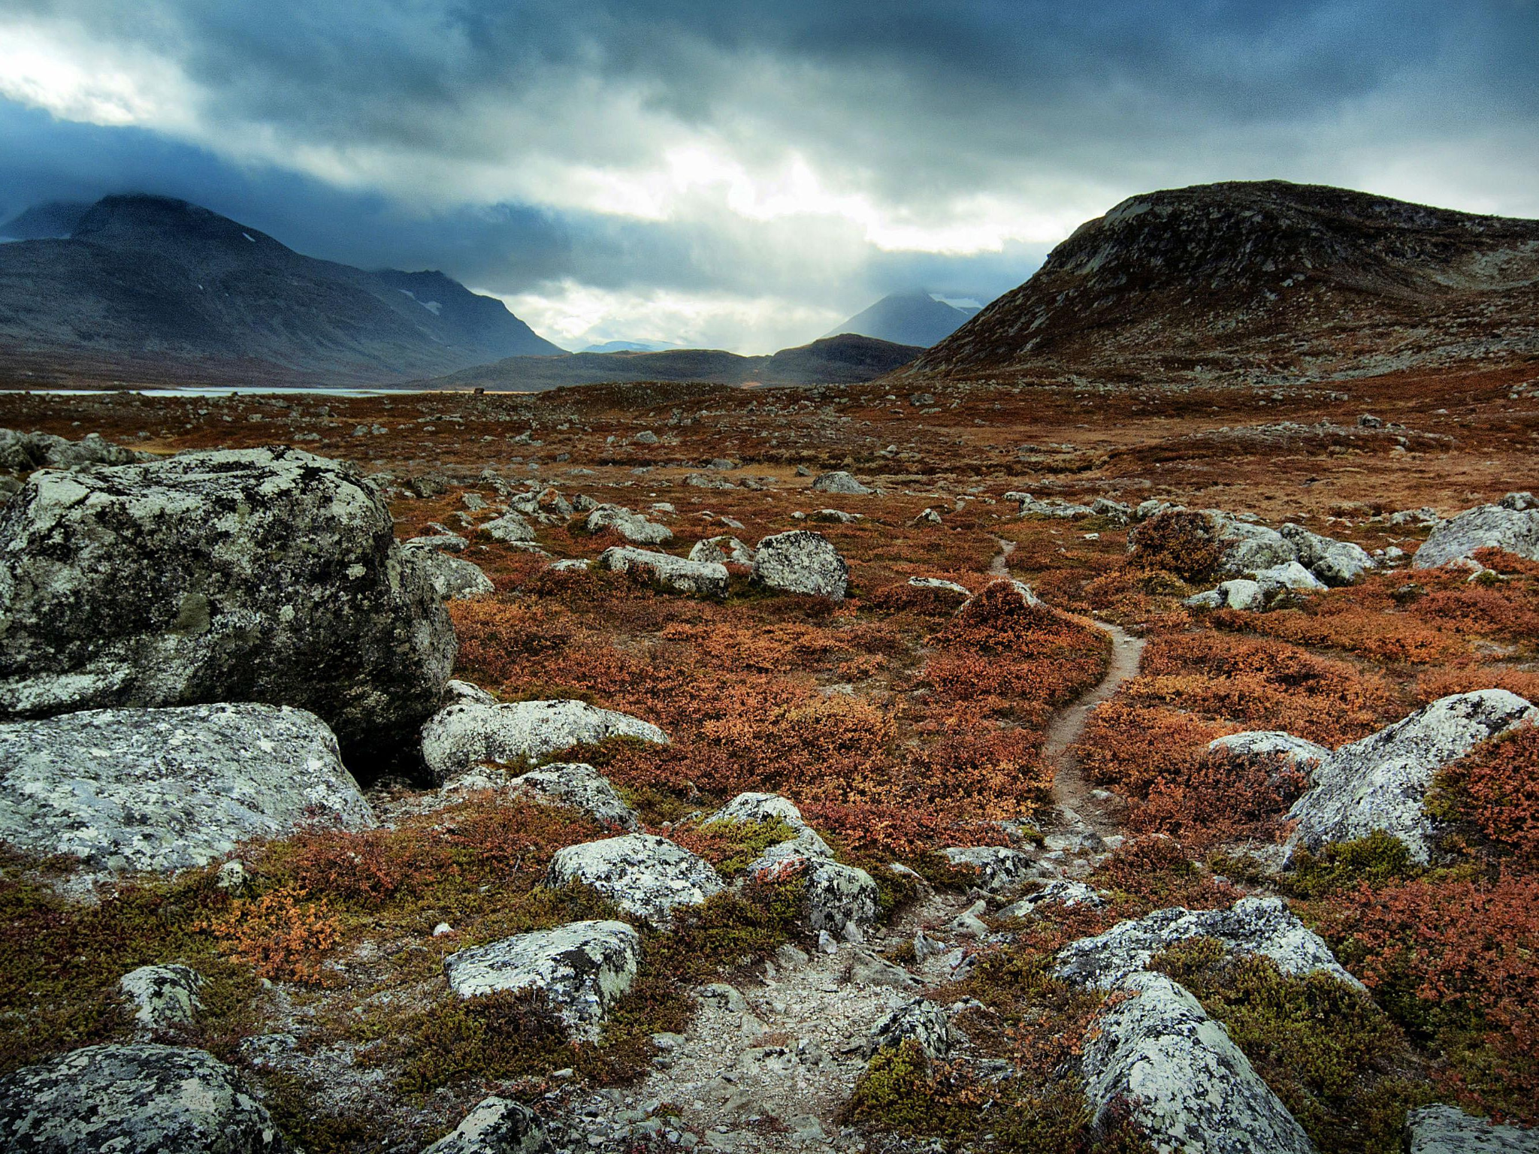
Part II: Content Module

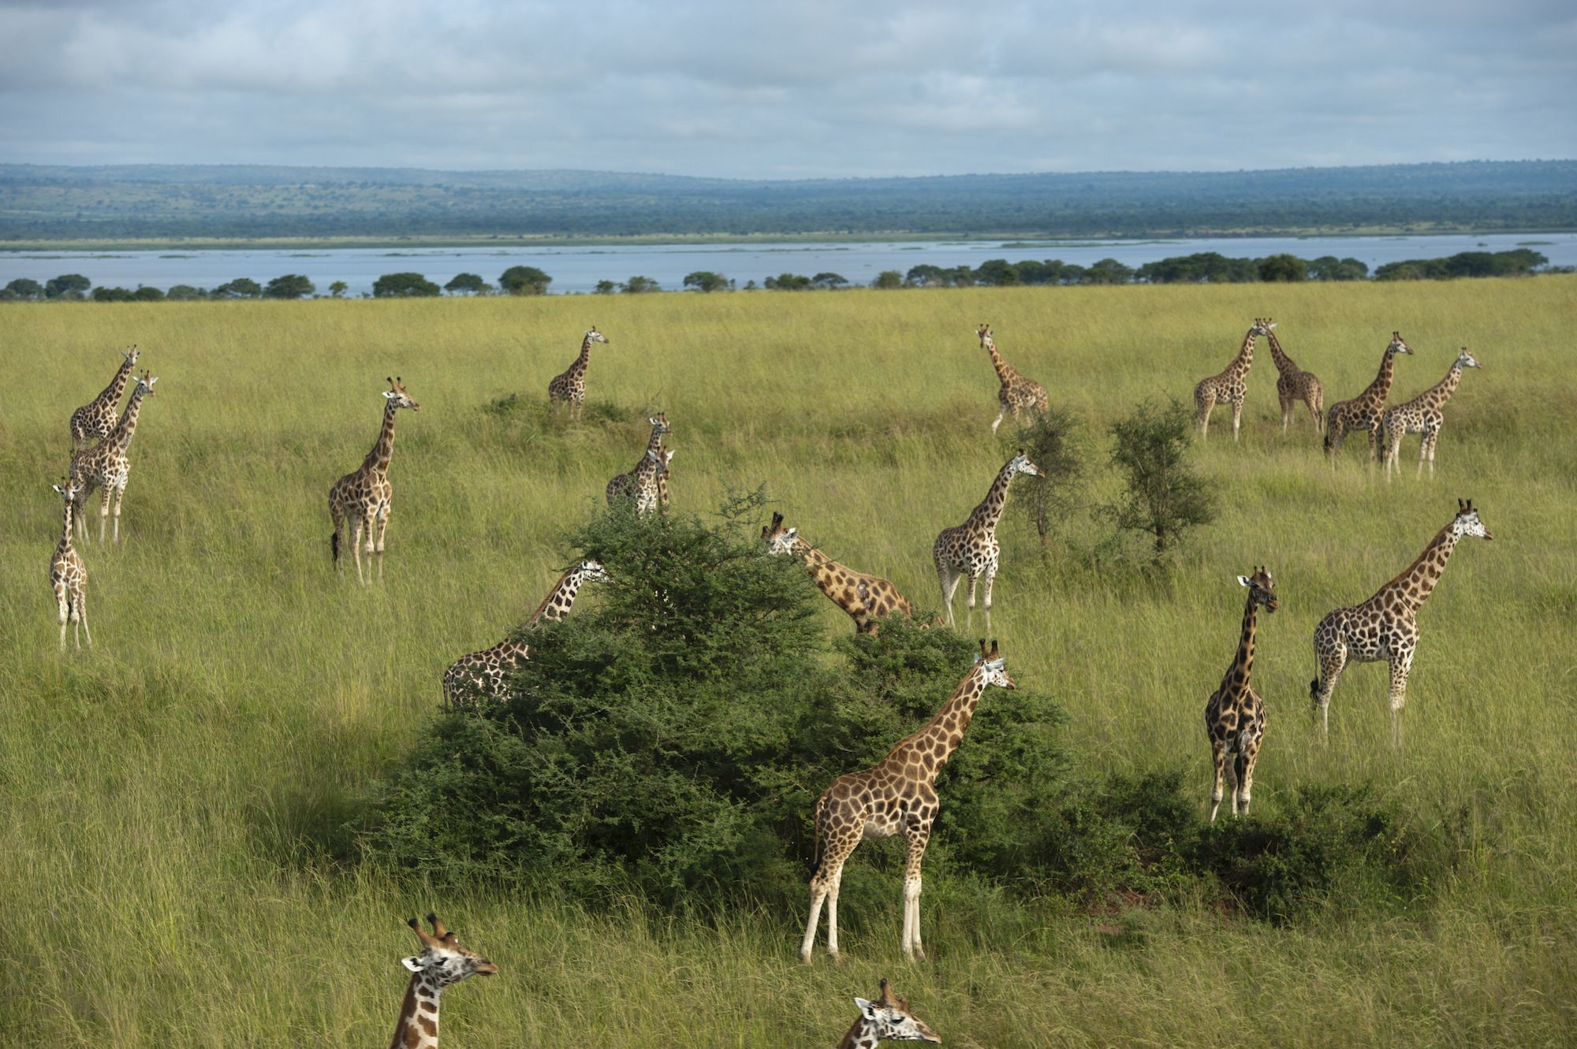
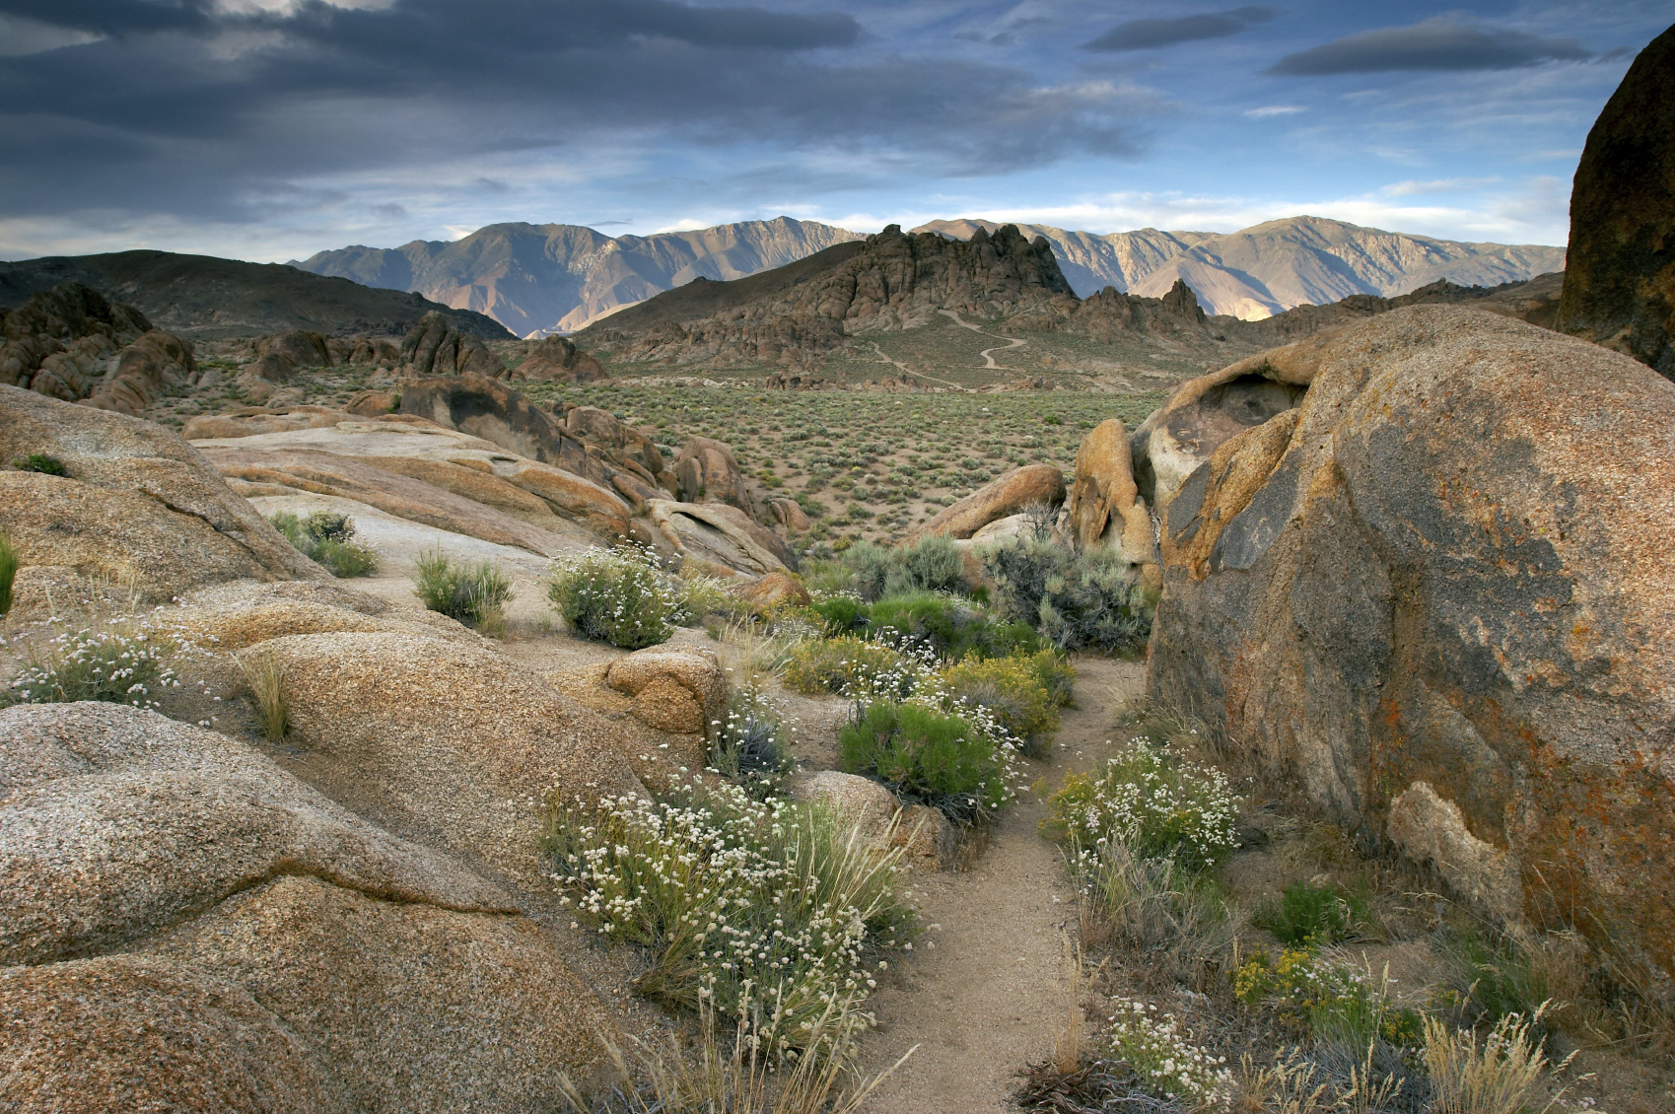

Sub-topic 1 Outline | The first sub-topics that this project will focus on are forest ecosystems. The mind map assignment supports the learning of this sub-topic because there are so many subcategories that the wildlife and plants within the ecosystem can
Objectives | Students will be able to create a model displaying the different characteristics of each ecosystem.  Students will be able to display the organisms that exist in certain environments  Students will be able to provide an explanation about why those specific organisms live in those ecosystems.
Instructions | Using kiddle.co as a resource and the mind-mapping tool Bubbl.us, create a mind-map that displays the differences between the different types of forest ecosystems.  - Use kiddle.co to research the different types of forest ecosystems  - Individually research each forest ecosystem and use the graphic organizer to take notes on the climate, animals, and plants of that type of forest ecosystem.  - Use Bubbl.us to create a mind-map displaying your findings. The mind-map should clearly display the differences in the climate, animals, and plants that live in that ecosystem Here are the requirements of the mind-map:  - Identify the type of climate  - Describe the climate in terms of temperature and humidity  - Display at least 3 different mammals, insects, and birds that live in each forest.  - Display at least 3 different plants that live in each forest.  - Provide a written response with a claim, evidence, and reasoning to support why one of the plants and animals lives in its specific forest.
Activity
Sample Mind Map
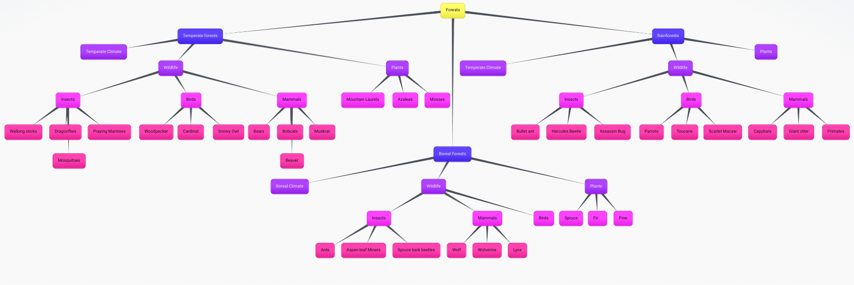
See a more-viewer friendly version of this activity using the link above.
References
Next Generation Science Standards. (2013). 3-LS4-4 Biological Evolution: Unity and Diversity |
Next Generation Science Standards.
https://www.nextgenscience.org/pe/3-ls4-4-biological-evolution-unity-and-diversity

Petro Jr., N. J. (2010). Hate taking notes? Try mind mapping. Gpsolo, 27(4), 20-23.

Nalder, J. (2009). Digital mind-mapping and visual organizers. A journey into new digital
learning possibilities. Primary & Middle Years Educator, 7(1), 7-11.

