Application of Mental Representations Lesson Plan

Nicholas Gurrieri
EDU 510
Dr. Mary Mills
Post University

Lesson Plan
Title: Representing Parts of a Whole with Number Bonds
Audience: k-12
Subject: Mathematics (Fractions)
Grade level: 3rd Grade
Time: 1 60 minute session
Overview: The lesson will begin with an initiation meant to display the learning goal for the lesson and break down itś
constituent parts. The body of the lesson, or the learning activities, will have students practice breaking apart whole numbers
into smaller parts. The students will practice applying this skill on a set of problems in a problem set, and then be assessed
on their ability to apply the learning independently with an exit ticket. The learning will conclude with a debrief with the intent
of revisiting the learning goal, where students will be able to self-reflect on their acquisition of the objective.
Objective: Students will be able to represent parts of a whole as fractions with number bonds
Materials: Student white boards (pockets)
Markers
Erasers
Student Rubric
Student problem set
Number bond template
Exit Ticket
SMARTboard
Activities
Initiation: Begin by reading the I CAN statement posted on the board for students ( I can represent parts of a whole as fractions with number bonds). Break apart the statement into key vocabulary words and ask students what words sound familiar or what words they need defined. Students may pick out words such as parts of a whole¨, ¨fractions¨, and ¨number bonds¨ as these words are familiar to students at this point in the module. Provide examples of real world ¨part-whole¨ relationships, such as pieces of a whole pizza or cake, number bonds with whole numbers, or rooms in a house (i.e. whole= kitchen, parts= chairs, stove, sink, counter, table) so students can come to understand the fact that a whole is made up by its constituent parts. Provide some of these visuals for students.

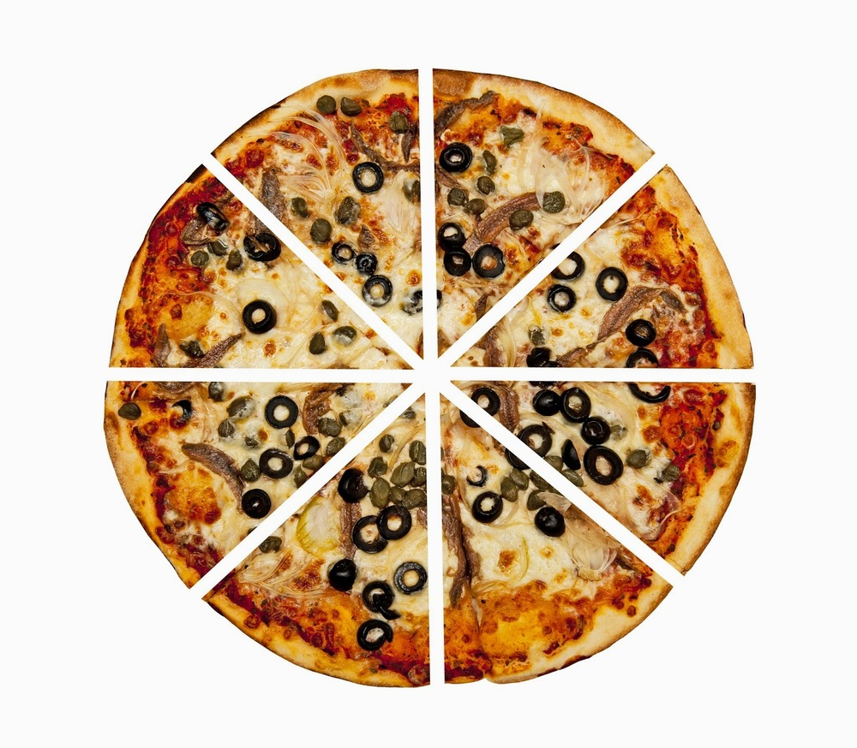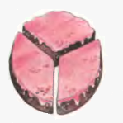
Kitchen
Chairs Table Windows Stove Microwave

Provide a visual of the student rubric, and go over how the students will demonstrate success. Go over success criteria and opportunities for extension. Then, pass out the number bond template for students to slide in their personal whiteboard.

Body of lesson: Part 1: Decomposing a whole number into parts.

Explain that today we will be decomposing whole numbers into parts. Provide the definition of decomposition and composition and an example. An example would include something akin to this:
Composition Decomposition
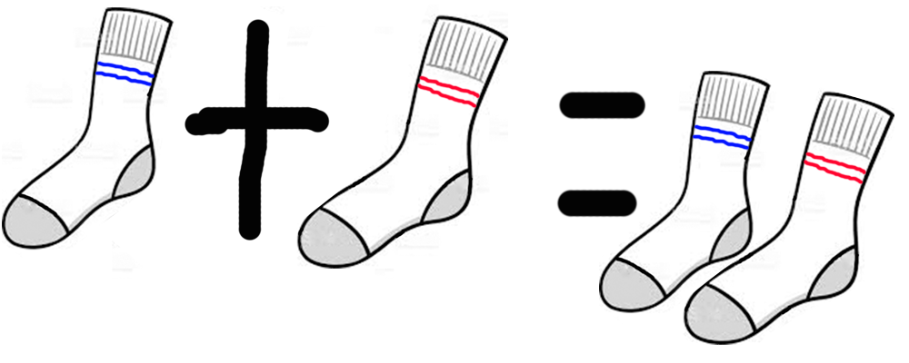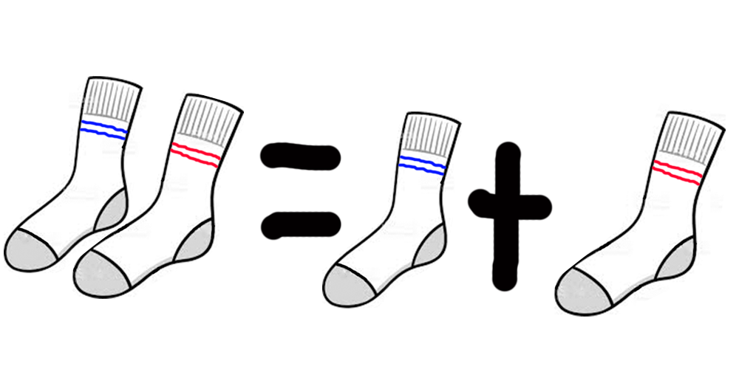
Provide a visual representation of a number bond with 4 wholes and 4 parts. Ask students: ¨If I had four pieces of cake, and wanted to decompose them, or split the pieces between 3 of my friends and myself, how would I split the pieces of cake up between my friends? Show how you would break up the whole on your number bond¨ The goal is to have students make this visual representation on their white boards. Circulate and provide feedback to students as they break up the whole into four equal parts:

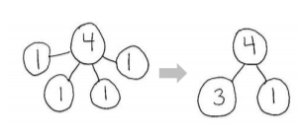
Provide a visual representation of the number bond with 4 wholes and only two parts. Fill in one of the parts with 3 wholes. Now, ask students: ¨Work with a partner for this next part. Assuming that I had had to break up my 4 whole pieces of cake into two parts, and one of those parts were 3 pieces of cake, how many pieces of cake would go in the other part of my number bond? Show how you would break up the whole on your number bond template.¨ The goal is to have students make this visual representation on their white boards. Circulate and provide feedback to students as they break up the whole into two parts. Provide opportunities for extension for advanced students by asking them to break up the whole in different ways or by changing the whole altogether.
Have students compare the differences between the two number bonds. Students may say things like ¨The first bond has the ones all separated. The second bond has 3 instead of 3 ones. Both bonds are different ways of showing the same number—4. You could also show 4 as one part 2 and one part 2. The first bond has more parts than the second one.¨

Part 2: Decomposing a whole into unit fractions

Now, students will draw a number bond decomposing 1 whole into 4 unit fractions. Instruct students to do the following: ¨Now, I want to see how you can break apart one of those parts into smaller parts. Now, we will look at 1 piece of cake as our whole (provide the visual for students showing 1 whole clearly in the top of your number bond). What do we know about the parts of a whole? (students may respond by saying ¨A part of a whole is smaller than the whole itself¨) When students say this, give students a hint that the parts of the number bond will be smaller than one whole. The goal is to get students to break one whole into 4 equal fractional units, like this:

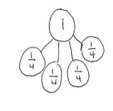
Now, students will draw a number bond decomposing 1 whole into 2 fractions, with one of the fractions being 3 copies of the unit fraction, and one of the other parts will be a unit fraction. Instruct students to do the following: ¨Now, work with your partner to show a number bond decomposing 1 into 2 parts. One part should be
composed of 3 copies of the unit fraction.¨ The goal is to have students break one whole into 2 fractions, ¾ and ¼, like this:
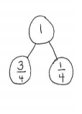
Have students discuss the differences between the two number bonds just as they did in the previous problem. Then, work with small groups to provide guided support to help students who need further instruction, and provide a challenge problem for students who are getting the concept. Have students break up 1 whole into 5 fifths, and 2 parts with the fractional unit as fifths. This is the idea:
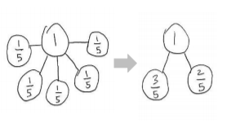
Provide time for students to work on the problem set, where they will look at a picture of a shaded and unshaded region of a shape split into equal parts, and make a corresponding number bond to show the shaded and unshaded part as the two parts of the whole.
Provide a visual example for students:
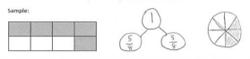
Debrief: Allow time for students to share their work on some of the problems in the problem set. Explain any misconceptions and provide extra support for struggling students. Connect the work students did in the problem set to the I CAN statement. Ask: How does todayś work relate to our objective?
Assessment: Draw a number bond that shows the shaded and the unshaded parts of the shape below.
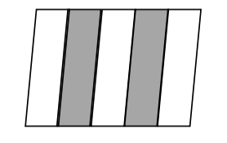

Lesson Details & Focus:
Mental Representation and Description | Examples) appropriate to the cited mental representation | List up to two ways or strategies employed in the lesson
Images | Number bond  Picture of pizza split into parts  Picture of cake split into parts  Flow chart of a kitchen split into itś constituent parts  Shapes split into equal parts  Decomposition and composition | Providing the visual of a number bond helps students see the abstract idea of a ¨part-whole¨ relationship. The whole of the number bond, or the top of the number bond, is broken apart into two or more parts. These parts come together into one whole. This is similar to the idea of the roots of a tree feeding into the trunk of the tree. The roots are the parts, and they come together to make the whole, i.e. the part of the tree we see.  The other images provided in the initiation of the lesson, like pizza, cake, or the flow chart showing the parts of a kitchen, serve to activate schema about part-whole relationships. This helps students make real world connections about an abstract idea.  The shapes split into equal parts with shaded regions, like the ones showcased in the problem set and exit ticket, help students see how part whole relationships can be observed with shapes. For example, a rectangle split into eights can have ⅜ shaded and ⅝ unshaded.  The images used to illustrate composition and decomposition show age appropriate examples of the concept. Decomposition means taking apart a whole into smaller parts (ab = a + b), while composition involves taking two parts and putting them together to make a whole (a + b= ab).
Analogies | Part-whole relationships  Decomposition  Composition | I used the analogy of pieces of pizza to illustrate a part-whole relationship.  I also referenced pieces of cake, or the room to a house like a kitchen to illustrate the concept of a part whole relationship. The idea of a part-whole relationship is that the constituent parts are smaller than the whole. This is important for the lesson because students need to know that the parts of a number bond can be combined to compose the larger whole, and the whole can be decomposed into the smaller parts  I used the analogy of putting together and taking apart a pair of socks to illustrate decomposition and composition. This is age appropriate and clearly shows a real world application of the terms composition and decomposition. Also, the cake and pizza analogy are used to illustrate these two concepts

- Provide any additional details required to define the content of your lesson plan.
  - Some additional information required for the lesson plan is the actual outline of the rubric that will be given to students so they can see how they will be able to demonstrate mastery of the concept. Here are the rubric parameters that students will use to evaluate themselves:
    - Indicator of Achievement: I can depict the unshaded and shaded portion of a shape using fractions with a number bond with two parts and one whole
- Summary of your understanding of the application of the ideas in teaching and learning.
  - The 2 mental representations that I featured in my lesson are images and analogies. According to ¨Cognitive Science: How to Improve your Teaching¨, there are a multitude of ways to help students process information. Of these techniques, imagery stands out as one that can help students process and retain information more effectively (Coaching for Better Learning, 2017). There is a close like between reasoning and mental imagery (Thagard, 2019) In this lesson numerous images were used to help visualize the difficult concepts in this lesson. Analogies are another type of mental representation featured in this lesson. They play an important role in human thinking and are effective in education and design (Thagard, 2019). Analogies are essentially comparisons, but teachers need to explicitly prompt students to engage in the use of analogies for them to be useful. For example, in previous studies, it has been shown that students need to compare correct and incorrect examples of analogies so they can see their usefulness. Other uses of analogies include verbally labeling the top, middle, and bottom components of a structure. This verbal analogy can be very useful for your students (Vendetti et. al, 2015) Human ability to use analogies is directly related to the representational abilities of the human at that time. As representational ability increases, the ability to use more complex analogies becomes easier. Cognitive processes that require analogy include the use of metaphors, conceptual blends, and math problem solving, to name just a few (Holyoak, Gentner, & Kokinov, 2001).
- Appropriate connections are made between your work, unit content, and class discussions.
  - I used images because of their usefulness in helping students retain information more effectively. Images like cakes, pizza, or a flowchart displaying the constituent parts of a room in a house are relatable and developmentally appropriate pictures that help students understand the idea of part-whole relationships. I used analogies as well. For example, the analogy I used for composition and decomposition included a comparison involving socks. Pairs of socks can showcase decomposition and composition because the socks can be taken apart from a pair and split into two individual socks, or the two individual socks can be put together to make a pair.
- Based on your work what changes do you envision for education, teaching and learning?
  - It is becoming more clear to me about the importance of using mental representations such as images, analogies, concepts, and deep learning experiences to ensure students are actually retaining information and able to apply what they have learned to a real world situation. I envision that more concept based learning is what takes place in classrooms, and there will be a greater emphasis on critical thinking. My hope is that education will be less focused on ¨seat time” and more time will be spent thinking about what students will know, do, and be able to apply, regardless of the time it takes.
- How does this lesson plan inform your understanding of the future of education in your professional setting?
  - This lesson plan informs me of the importance of using strategies to assist students in making stronger neural connections. Envisioning this lesson without using mental representations like images or analogies is a daunting prospect. The lesson simply would not be as strong, and I think that the inclusion of images and analogies makes this a lesson that all students would succeed in.

References
Coaching For Better Learning. (2017, May 22). Cognitive Science: How to Improve Your
Teaching. YouTube. Retrieved from https://www.youtube.com/watch?v=tMEOpYpaswc&feature=youtu.be
Holyoak, K.J., Gentner, D. & Kokinov, B. (2001). Introduction: The place of analogy in cognition.
In D. Gentner, K.J., Holyoak, B.N., and Kokinov, B. (Eds.). The analogical mind: Perspectives from cognitive science. (pp 1-19). MIT Press.
Thagard, P. (Spring, 2019, Edition). Cognitive science. In Edward N. Zalta (ed.). The Stanford
Encyclopedia of Philosophy.
Vendetti, M. S., Matlen, B. J., Richland, L. E., & Bunge, S. A. (2015). Analogical Reasoning in
the Classroom: Insights From Cognitive Science. Mind, Brain & Education, 9(2), 100–106.

